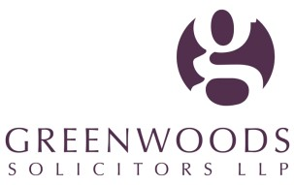
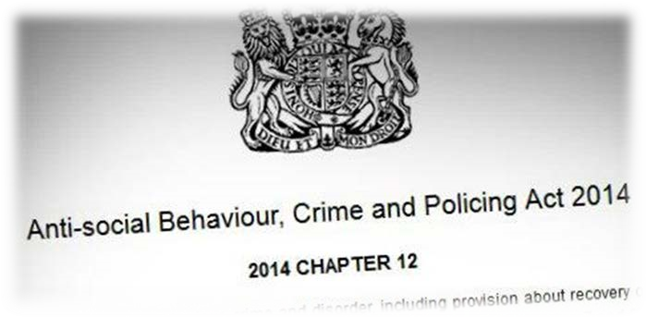

Insight: Foresight
Hospitality Sector
When can you be liable for
Child Sexual Exploitation (CSE)?
What are your liabilities should your property be used
by those engaged in CSE crime?

Richard Barraclough QC, 6 Pump Court, will consider:
•
when a hotel will be liable in negligence for CSE
•
recent judgments
•
steps needed to protect you and your reputation

Kathryn Gilbertson, Director, Greenwoods Solicitors LLP, will discuss:
•
the Anti-social Behaviour, Crime and Policing Act 2014
•
Police actions
•
next steps to manage risk

Whether you are new to safety or someone who has practised in the field
for
many
years,
our
‘Insight:
Foresight’
masterclass
will
provide
a
practical and useful legal update to this topic.

If you are a health and safety professional or business owner you will
benefit from the insight our experts will bring.

Join our Forum

Date:

Thursday, 5 November 2015

Venue:

RSA House, 8 John Adam Street

London, WC2N 6EZ

Registration:

9.30
am

Start:

am
9.45

Close:

pm – post-event
12.30

refreshments & networking from

12
noon
RSVP:

Leah Pearson

T : 01733 887817

E : lvpearson@greenwoods.co.uk

Working with You  Described by Chambers UK as 'excellent in every respect‘, Greenwoods'  Regulatory team delivers commercial advice aimed at minimising risks. Our experts work with organisations' internal environmental, health, safety and  quality teams. They pride themselves on delivering effective strategies – not  just standard legal solutions.  The team often visits work places to audit and advise on potential  compliance risks (including personal liability for directors and senior compliance risk managers) together with reviewing existing documentation and drafting policies and procedures where these are missing.  Many organisations work in partnership with contractors and with the  assistance of agency staff, situations which can put their compliance culture and their reputation at risk. Our team frequently advises clients on the  assessment of such risks with the aim of ensuring a safe commercial solution.  Our convictions team has in the successfully Court of advised, Appeal defended and has and the appealed technical regulatory skills and knowledge to help you chart the right path.  Guest speaker :  Richard Barraclough QC _{Six Pump Court}  Richard Barraclough QC is a Common Lawyer whose vast experience in civil and criminal matters has been acquired  over more than 30 years of a practice. Richard is a  Protection and child abuse matters. recognised expert in jury trials in Regulatory, Consumer  He advises major hotel chains on the potential liability (from both UK and US law and practice perspective) in relation to possible claims for child exploitation where structure, management, staffing and systems are considered. He also acts for hospitals, schools, insurers and local authorities in this field. | Greenwoods Solicitors LLP’s hosts:  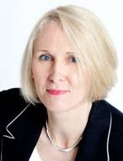  Kathryn Gilbertson, Director and Head of Regulatory  Kathryn Gilbertson is head of Greenwoods’ renowned  Regulatory team. A leader in the field of regulatory law, Kathryn, with the support of her team, has represented numerous companies in trials concerning fatal accidents, major workplace incidents and safety issues.  Charlotte Murray, Chartered Legal Executive  Charlotte, a qualified legal executive, supports the team with all aspects of case preparation and the day-to-day management of cases. Charlotte is well-known for her enthusiasm and her ability to get answers to those  ‘difficult’ questions.  About Greenwoods Solicitors LLP  London | Peterborough | Cambridge  Greenwoods Solicitors LLP is a fast-growing regional commercial firm with an excellent reputation and a national and international client base. We pride ourselves on delivering a ‘City level’ of quality and responsiveness - built on high calibre lawyers, but marked by a personal approach.  Our Peterborough office is served by superb transport links so is ideally situated for clients throughout the country. Our Cambridge office is in Vision Park, Histon, just off the A14. In London we are based in Temple – the heart of legal London.  www.greenwoods.co.uk  Stay in touch:  Follow us on Twitter  @Greenwoods_Law  Join us on LinkedIn

