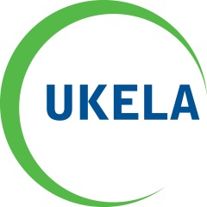
GLSEnvironment

Joint Seminar – UKELA and GLS

Paris and beyond
- An analysis of the UNFCCC negotiations and Paris Agreement, and implications for UK practitioners

Early evening seminar looking at the climate conference in Paris in December 2015. Hear the inside line on the negotiations from those that were present. Find out about key provisions of the Paris Agreement, and what it means for carbon markets and renewables.

Date: Monday 21 March at 5.30pm (registration from 5pm)
Venue: Nobel House, Smith Square, London, SW1P 3JR

Programme (1.5 CPD)

5.30pm: Welcome by Jolyon Thomson, Defra’s Deputy Director, International, EU and Knowledge Management
Chair’s introduction: Stephen Hockman QC, 6 Pump Court

5.40pm: Caroline Ross, lead UK lawyer for the Department of Energy and Climate Change at COP21 – Reflections on the negotiations and the terms of the Agreement
6pm: Christoph Schwarte, Executive Director Legal Response Initiative - Supporting poor and particularly climate vulnerable developing countries, and civil society observer organisations in Paris
6.20pm: Francesco Sindico, Reader in International Environmental Law, University of Strathclyde - An international lawyer's analysis of the Paris Agreement, in particular the mechanisms for enforcement, compliance and transparency.

6.40pm: Melanie Shanker, Managing Associate, Linklaters - What does the Paris Agreement mean for carbon markets and renewables investment?
7pm: Panel Q&A

The seminar concludes at 7.30pm – Delegates are welcome to stay and discuss the issues raised over a cup of tea/coffee

Thank you to our chair and speakers. We hope you enjoy the evening.

